UNIT 2 SCHOOL
Periods 2: New words- Reading-Grammar ( page 17,18)
- NEW WORDS: ( viết vào tập)
Words | Kinds of speech | Pronunciaion | Meanings
- act | (v) | /ækt/ | diễn xuất
- activity | (n) | /ækˈtɪvəti/ | hoạt động
- indoor ≠ outdoor | (adj) | /ˈɪndɔːr/ /ˈaʊtdɔːr/ | trong nhà ≠ ngoài trời
- sign up = register | (v) | /saɪn ʌp/ | đăng ký
5.arts and crafts | (n) | /ɑːrt ənd krɑːfts/ | thủ công mỹ nghệ
- drama club | (n) | /ˈdra: mə klʌb/ | câu lạc bộ kịch

- GRAMMAR ( viết vào tập)
- Like + V-ing
- Talking about things we like to do often
Ex: I like listening to music
My father likes reading newspapers.
- Do you like ……..? (viết vào tập)
YES
Yes, I do
Yes, I really like it
Yes, that’s my hobby.
Of course. I …. everyday
NO
No, I don’t.
No, not really.
No. I like …
- PRACTICE
Exercise 1 : Put the following words in the correct columns: ( viết vào tập)

Arts and crafts, soccer, table tennis, volleyball, billiard, swimming, chess, cycling, skiing.

Indoor activities | Outdoor activities
-  -  -  -  - | -  -  -  -  -

Exercise 2 . Look at the pictures and do the crossword puzzle:
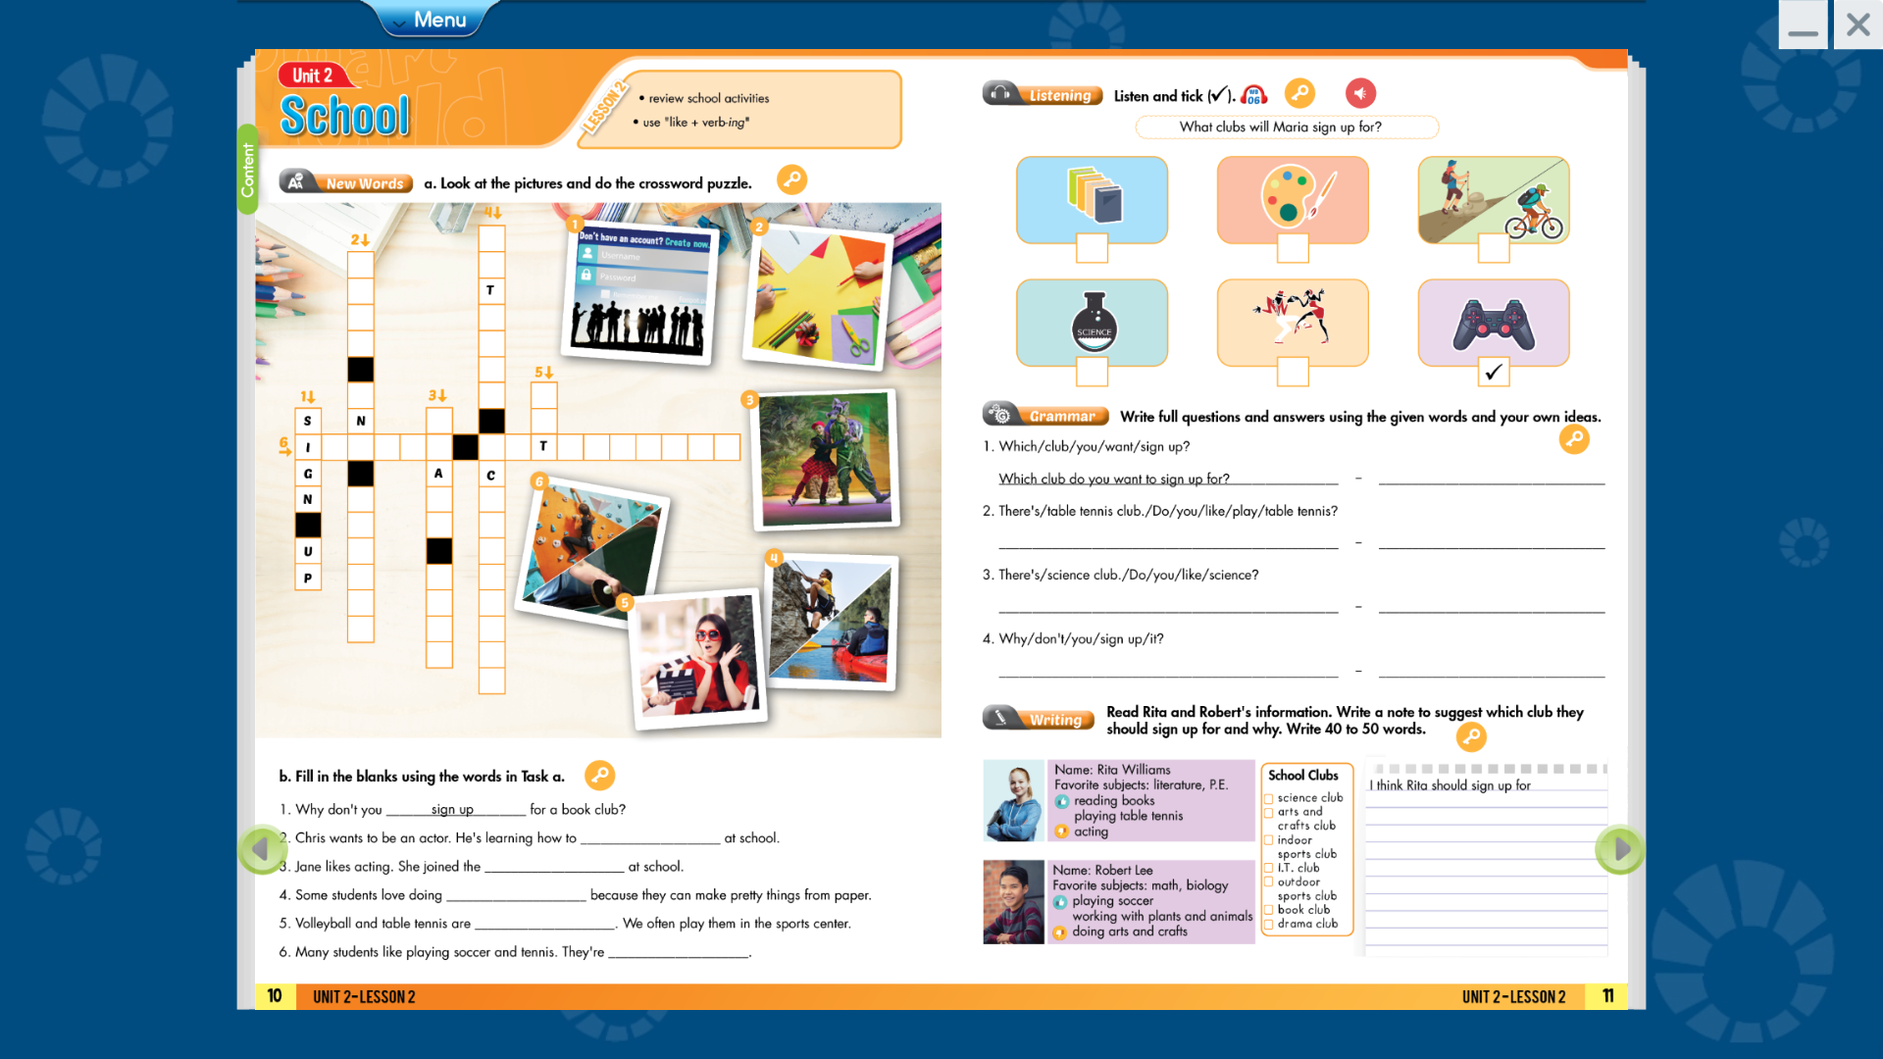

- ………………………
- ………………………
- ……………………..
- …………………….
- …………………….
- …………………….

Exercise 3: . Fill in the blanks using the words in Exercise 2. ( viết vào tập)
1. Why don't you sign up for a book club?
2. Chris wants to be an actor. He's learning how to ________________ at school.
3. Jane likes acting. She joined the ________________ at school.
4. Some students love doing ________________ because they can make pretty things from paper.
5. Volleyball and table tennis are ________________ We often play them in the sports center.
6. Many students like playing soccer and tennis. They're ________________ .


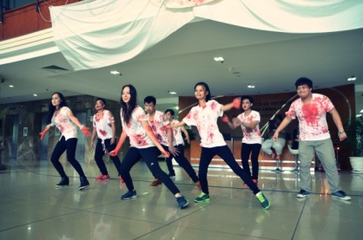


Homework: Write four dialogues for these pictures
1
3
4
2

Ex :
A: There’s a book club . Do you like reading?
B: Of course. I read books everyday.

